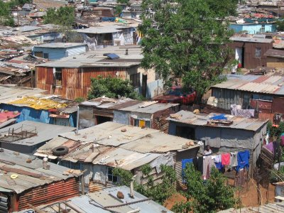
Where Are Shanty Towns Found?
What is a shanty town?

Many people leave the countryside out of desperation and move to cities even though they are aware the conditions are not good. The reasons for this move can be divided into push and pull factors. Push factors push people out of the villages and countryside, whereas Pull factors attract people to the city.
The people who arrive in the city are usually very poor. They have come from the countryside believing the city will be a better place to live providing them with jobs, money and a brighter future for their families.
Push Factors | Pull Factors

Imagine you have moved to the city alone with all your possessions. You have $30 (£19.25). What are your top three priorities on arriving in the city and why?
Priority: Why:
1.
2.
3.
Somewhere To Stay?
These places are free for you to build houses on. What are the advantages and disadvantages of living in these places?
Place | Advantage | Disadvantage
Banks of a river
Steep slopes
End of airport runway
Landfill site
Next to pesticide factory
25km from centre of town
In a cemetery
Where would you decide to build your house and why?

